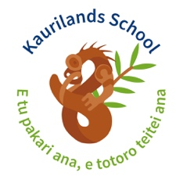

Dear Parents

As part of our studies about Earth, Sun and Moon the year 1 classes will be going to the Stardome Observatory on the 17th May.

Rooms 21, 22, and 24 will be leaving school at 9.00 and returning at 1.00
Rooms 19, 20, and 23 will be leaving school at 11.00 and returning at 2.50

Please ensure your child has lunch and a drink bottle.

We require a limited number of parents to help with supervision. No preschoolers please.

If you are able to help with supervision, please indicate below.

I am able/unable to help with supervision on the Stardome trip. Please circle one.

Childs Name

Parents Name

Dear Parents

As part of our studies about Earth, Sun and Moon the year 1 classes will be going to the Stardome Observatory on the 17th May.

Rooms 21, 22, and 24 will be leaving school at 9.00 and returning at 1.00
Rooms 19, 20, and 23 will be leaving school at 11.00 and returning at 2.50

Please ensure your child has lunch and a drink bottle.

We require a limited number of parents to help with supervision. No preschoolers please.

If you are able to help with supervision, please indicate below.

I am able/unable to help with supervision on the Stardome trip. Please circle one.

Childs Name

Parents Name

